Software Requirements Specification

for

Crossing Boarders
Version 1.0

Prepared by

Brandon Williams | 620149140 | bw6751430@gmail.com

TABLE OF CONTENTS

1 Overall Description
  - Product Context and Need
  - Product Functionality
  - Stakeholders and Users Characteristics
  - Operating Environment
  - Design and Implementation Constraints
  - Assumption and Dependencies

- Specific Requirements
  - External Interface Requirements
2.1.1 Hardware Interface
2.1.2 Software Interface
2.1.3 Communication Interface
2.2 Functional Requirements
2.3 Behaviour Requirements
2.3.1 Use Case Views

3. Other Non-functional Requirements
3.1 Performance Requirements
3.2 Safety and Security Requirements
3.3 Software Quality Requirements

4. Other Requirements

Revisions
Version | Primary Author(s) | Description of Version | Date Completed
Draft 1 | Brandon Williams | This is the initial version of the Software Requirements Specification document. | 31/1/2026

.

Overall Description

Product Context and Need

Product Context
The University of the West Indies (UWI), established in 1948, is a major regional public university serving the diverse group of students from over the Caribbean. UWI offers hundreds of programmes at certificate, diploma, undergraduate, and postgraduate levels across many fields. Its mission is to offer advance learning, creating knowledge, and foster innovation to support development in the Caribbean and beyond.

Product Need
The University offers top tier education, however, many of its students fail to grasp concepts and understand how those concepts are applied in the working world. Currently, the university offers a blend of teaching methods, online and face-to-face, giving students the option to engage in in-person discussions or to join in the discussion from the comfort of their home. Although information from lectures is made available through the university’s online learning platform (VLE), many students still struggle to digest their content, typically turning to third party application such as ChatGPT and YouTube for explanation and clarity.

Product Functionality
- Users will be able to upload lecture documents to the system.
- Users will be able to prompt the system to carry out a specify task.
- The system will encrypt and store conversations with users for a limited time.

Stakeholders and Users Characteristics
Users – The system will allow users to upload and enter prompt for a specific to be done. Users are key stakeholder, as they will be directly impacted by the system.

Regulatory Authorities – Will enforce the rules, policies, and standards that define the legal, safety, and quality requirements of the system. As stakeholders, their policies and standards ensure that the system meets ethical and safety guidelines before its release to the public.

Operating Environment
The software will be developed as a downloadable application, hosted on the user’s device, and will run on machines with Windows 10 or 11, Android, and IOS operating systems.

Design and Implementation Constraints
- Since the company will be dealing with sensitive data, advance encryption methods will be required to secure applicants information.

Assumptions and Dependencies
- Allure Dream Vacation will have their own cloud base or centralized database.

Specific Requirements

External Interface Requirements

Hardware Interfaces
- Supported Device Types:
  - Desktop PCs, Laptops (e.g., Lenovo ThinkPad X1 Carbon)
- Processor: 11th Gen intel i5Primary Memory: 4GB
- GPU: Integrated Graphics
- Operating System: Windows 10 Pro, windows 11
- Resolution: 1920x1080
  - Tablets and smartphones
  - Storage: Minimum 256 SSD
- Peripheral devices
- Input Devices: Keyboard and mouse for user input.
- Output Devices: Monitor (minimum resolution 1920x1080) displays the graphical user interface (GUI).

Control Interactions:
- User commands (e.g., clicks, keystrokes) are captured and processed by the software.
- Software updates the UI in response to user interactions.

Supported Device Types:
- Solid State Drives (SSD) with a minimum capacity of 256GB.

Nature of Data Interactions:
- Read and write operations for data storage and retrieval.

Control Interactions:
- Software issues commands to read from or write to the SSD, managing file systems and data integrity.

The User Interface: The user interface allows users to interact with the software through input devices (keyboard and mouse) and receive output on a display monitor. It captures user commands and provides visual feedback, enabling intuitive navigation and control within the software.

Storage Interface: This interface manages data storage and retrieval on the device’s internal storage (SSD). It handles read and write operations, ensuring data integrity and efficient access to files and databases used by the software.

Graphics Interface: The graphics interface facilitates the rendering of visual elements on the display. It communicates with the integrated graphics hardware to execute rendering commands, ensuring that the software's graphical user interface (GUI) is displayed correctly and efficiently.

Network Interface: the network interface enables communication between the software and external networks. It supports both wired (Ethernet) and wireless (Wi-Fi) connections, allowing data exchange with web services, APIs, and online databases.

Software Interfaces
This product will operate on an Apache HTTP Server hosted on Oracle Linux. The web application will be accessible through web browsers installed on client machines, allowing users to interact with the software seamlessly.
To ensure robust security for sensitive data, a firewall will be implemented on the server alongside Apache. This layered security approach will help protect against unauthorized access and potential threats while delivering web content securely to users.
Additionally, the application will utilize RESTful APIs to facilitate communication between the front-end interface and the back-end services, ensuring efficient data exchange and integration with other systems.

2.1.3 Communications Interfaces
Data is exchanged between the server and client devices over a secure intranet network maintained by Allure Dream Vacations. This network facilitates communication between machines hosting the software application and any associated databases or services. The primary protocol for web-based interactions will be HTTP, allowing users to access the application through web browsers. To enhance security, all communications will be encrypted using SSL/TLS, ensuring that sensitive information remains confidential during transfer.
For data integrity and security, the system will back up information to an external cloud storage solution using secure data transfer protocols such as VPN, SSH, and/or SFTP. This backup process will occur after a user-defined interval, ensuring that critical data is consistently protected and easily retrievable in case of system failures or data loss. Additionally, the application will utilize RESTful APIs for efficient interactions with back-end services, promoting reliable data exchange and synchronization between client devices and the server.

Functional Requirements
Requirement 1: Application Portal
Use Case: Online Submission of Immigration Applications
Rationale: An online portal for applicants is essential to streamline the submission process, making it more convenient and efficient. Currently, applicants may face delays due to manual processes.
User Requirement: The system shall allow applicants to submit personal and immigration details online.
System Requirements:
- The system shall provide an interface for uploading required documents (e.g., passports, visas).
- The system shall facilitate the verification of uploaded documents for authenticity.
- The system shall organize uploaded documents in a specified format (e.g., date in which documents are uploaded).
- The system shall confirm application submission via email.
Acceptance Criteria:
- The system allows applicants to successfully submit personal and immigration details online without errors.
- The document upload functionality works for required files.
- The system will allow for documents to be uploaded in a specified format (e.g., PDF, Docx).
- Uploaded documents are stored and can be accessed and categorized.
- The system can verify the authenticity of the uploaded documents.
- Confirmation emails will be sent 15 seconds after submission.
Relates to/Dependencies: None
Priority: High
Team Owner Shanice Thompson and Javannio Reid

Requirement 2: Application Tracking
Use Case: Monitor Immigration Application Status
Rationale: Providing real-time updates on application status helps manage applicant expectations and reduces inquiry overload.
User Requirement: The system shall provide real-time status updates for applicants on their immigration process.
System Requirements:
- The system shall provide real-time update tracking of application status.
- The system shall notify applicants when there are changes in applicants’ application status.
- The system shall create a history of all application status changes.
- The system shall display the changes of application statuses.
Acceptance Criteria:
- Status updates are available in real-time through the applicant portal.
- Applicants receive notifications regarding changes in their application status in no more than 10 seconds.
- The system will record and store the changes in applicants’ application status.
- The system will display the history of changes in applicants’ application status in no more than 10 seconds.
Relates to/Dependencies:
- Application Portal
Priority: High
Team Owner: Shanice Thompson

Requirement 3: Agency Admin Dashboard
Use Case: Centralized Management of Applications
Rationale: A centralized dashboard for agency administrators enhances workflow and application management.
User Requirement: The system shall display a centralized dashboard for managing all applications.
System Requirements:
- The system shall allow for deactivating, and deletion of applicants’ accounts.
- The system shall allow for the creation and management of notifications.
- The system shall allow filtering and searching of applications by type, name, date, ID number, or country.
- The system shall provide tools for communication with applicants directly from the dashboard.
Acceptance Criteria:
- Administrators can filter and search applications in no more than 20 seconds.
- Communication tools are integrated and accessible from the dashboard.
- Administrators can create and send notifications to applicants in mass or directly.
- Administrators can delete, alter, and rebroadcast existing notifications.
- Administrators can successfully deactivate or delete applicants accounts.
Relates to/Dependencies: None
Priority: High
Team Owner: Brandon Williams

Requirement 4: Telecommunication
Use Case: Facilitate Communication between Agency and Applicants
Rationale: Effective communication is vital for addressing applicant inquiries and providing responses.
User Requirement: The system shall support an in-portal messaging system for communication between the agency and applicants.
System Requirements:
- The system shall provide a channel through which applicants can directly communicate with employees.
- The system shall log the messages sent between applicants and employees.
- The system shall provide automated responses for common queries.
- The system shall enable direct email support for additional communication.
Acceptance Criteria:
- Applicants can communicate with the agency through the in-portal messaging system.
- The system will create a history of the messages sent for stateful communication.
- Message will be sent and received in no more than 10 seconds.
- Message will be encrypted before being transmitted.
- Automated responses function correctly for predefined queries.
Relates to/Dependencies: Admin Dashboard
Priority: Medium
Team Owner: Brandon Williams

Requirement 5: Security and Compliance
Use Case: Ensure Data Security and Compliance
Rationale: Protecting sensitive applicant data is paramount for maintaining trust and adhering to legal standards.
User Requirement: The system shall ensure data encryption for secure transmission and storage of sensitive information.
System Requirements:
- The system shall implement role-based access control to protect applicant data.
- The system shall sanitize and encrypt data before storage.
- The system shall adhere to international data privacy standards (e.g., GDPR).
- The system shall encrypt all messages sent through the system.
- The system shall perform data checks on messages and documents to ensure their integrity.
Acceptance Criteria:
- Messages are encrypted at both ends to ensure privacy.
- All sensitive data is encrypted during transmission and storage.
- Data checks are performed 4 times each week by the system to ensure integrity.
- Verificatory notifications about data’s security are sent to administrators.
- Role-based access control is implemented and enforced.
Relates to/Dependencies: None
Priority: High
Team Owner: Shemar Mills

Requirement 6: Payment Processing
Use Case: Manage Application Fees
Rationale: Enabling secure online payments simplifies the fee collection process and improves the user experience.
User Requirement: The system shall enable secure online payments for application fees through integrated payment gateways.
System Requirements:
- The system shall support various payment methods for user convenience.
- The system shall create a logging history of payments.
- The system shall allow for refunds and cancellations.
- The system shall allow for scalability.
Acceptance Criteria:
- Applicants can successfully make payments through the system.
- Payment processing is secure and takes no more than 15 seconds, with confirmations sent to applicants.
- Applicants can make payments using credit cards, debit cards and bank transfers.
- The system will create a log history of the payments made by applicants.
- Applicants can successfully request refunds and cancel an application process through the system.
- The system will be able to process up to 300 transactions per day.
Relates to/Dependencies: None
Priority: High
Team Owner: Tahjric Allen

Behaviour Requirements

Use Case View
A use case defines a goal-oriented set of interactions between external actors and the system under consideration. Below is a use case diagram encapsulating the entire system and its possible actors.
Use Case Diagram:
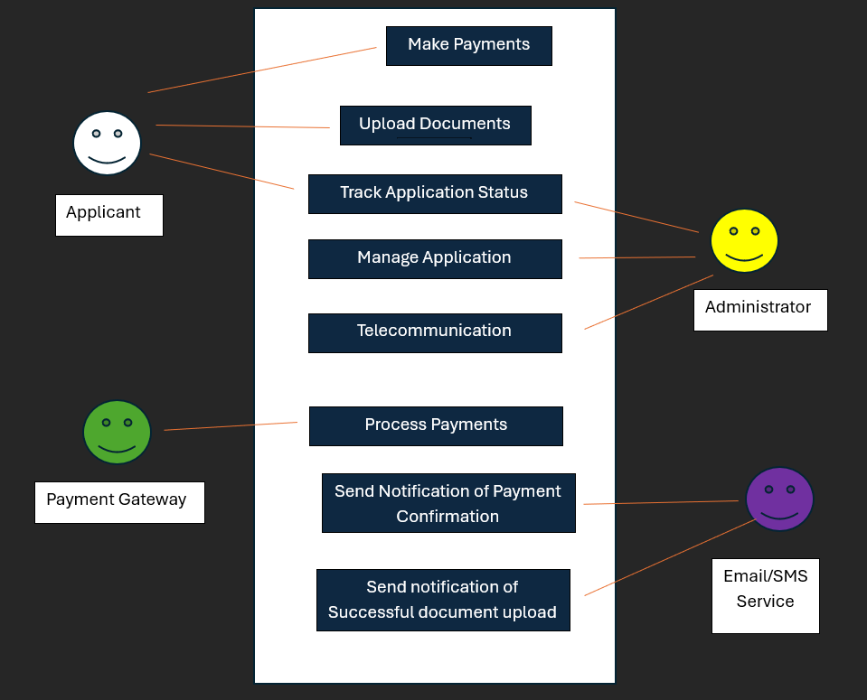

2.3.2 Use Case Narratives
- Name: Online Submission of Immigration Applications
Related Requirements: Applicants Upload Required documents.
Goal in Context: To have applicants upload the supporting documents relevant to their immigration application process.
Description: Applicants submit personal information and immigration documents through the system.
Primary Actors: Applicants
Triggers: The applicant wishes to upload a document.
Precondition: Applicant has an account and is logged into the system. They are required to upload supporting documents for their application. All necessary documents are prepared for upload.
Basic Flow:
- The applicant logs into the portal.
- The applicant fills out the required forms with their account credentials that were entered upon opening/signing up for the account.
- The applicant uploads necessary documents (e.g., passport, visa).
- The system then validates the completeness of the submission.
- The system sends a confirmation email to the applicant, if the submission was successful.
Post-condition: Application is successfully submitted, and the applicant receives a confirmation email.
Fail Post-Condition: Error message displayed outlining error with submission (file size, file type etc…).

- Name: Track Immigration Application Status
Related Requirements: [1] Track the status of application
Goal in Context: Allows the applicant to track the status of their application in real time.
Description: The system provides real-time status updates on the applicant's immigration process.
Primary Actor: Applicant
Secondary Actor: Administrator
Trigger: Applicant wishes to check on the current status of their application.
Precondition: Applicant has successfully submitted an application, and the application is being processed.

Basic Flow:
- The applicant logs into the portal.
- They Navigate to and selects view the status of my current application.
- The system retrieves the current status of the application.
- The applicant views the current status (e.g., "Under Review," "Approved").
- The applicant receives notifications for any status changes via email/SMS.
Successful Post-condition: Applicant has real-time access to their application status.
Fail Post-Condition: System fails to retrieve application information.

- Name: Centralized Management of Applications
Related Requirements: []
Description: Administrators manage all immigration applications through a centralized dashboard.
Primary Actor: Administrator
Trigger: Administrator wishes to check or process applications.
Precondition: Administrator has the necessary access rights.
Basic Flow:
- The administrator logs into the system.
- The administrator accesses the dashboard.
- The administrator views, searches, and filters applications by type, name, or other criteria.
- The administrator manages communication with applicants from within the dashboard.
Post-condition: Administrator has full access to manage and communicate about applications.
Fail Post-Condition: Administrator will not be able to access applications.

- Name: Secure Online Payment Processing
Related Requirements: []
Goal in Context: The applicant should be able to pay the fees related to the immigration and application related fees.
Description: Applicants make secure online payments for application fees.
Primary Actors: Applicants
Precondition: Applicant has completed the document submission process and is ready to pay.
Basic Flow:
- The applicant selects the payment option.
- The system presents available payment methods.
- The applicant selects a payment method and submits payment information.
- The payment gateway processes the transaction.
- The system confirms successful payment and sends a confirmation email.
Successful Post-condition: Payment is successfully processed and confirmed.
Fail Post-Condition: Payment fails.
- Name: Telecommunication between Applicants and Administrators
Related Requirements: [3], [2]
Goal in Context: Facilitate direct communication between applicants and administrators to address inquiries or request additional information.
Description: Administrators communicate with applicants directly through the system, sending messages or requesting more documents.
Primary Actor: Administrator
Secondary Actor: Applicant
Trigger: Administrator needs to communicate with an applicant regarding their application.
Precondition: Applicant has submitted an application, and the administrator needs further clarification or information.
Basic Flow:
- The administrator accesses the applicant's profile through the dashboard.
- The administrator sends a message requesting more information or documents.
- The system stores the communication log for future reference.
- The applicant receives a notification of the new message or request via email/SMS.
- The applicant responds or takes the necessary action.
Successful Post-condition: Communication between administrator and applicant is logged, and the requested action is taken.
Fail Post-condition: Applicant does not receive the message, or communication is unsuccessful.

- Name: Send Notification of Payment Confirmation
Related Requirements: [4].
Goal in Context: Notify the applicant when their payment has been processed successfully.
Description: The system sends a payment confirmation notification via email or SMS after payment is completed.
Primary Actor: Payment Gateway
Secondary Actor: Applicant
Trigger: Payment is successfully processed.
Precondition: Applicant has submitted payment through the system.
Basic Flow:
- The Payment gateway processes the payment.
- The system sends a confirmation notification via email/SMS to the applicant.
- The applicant receives confirmation that their payment has been completed.
Successful Post-condition: Applicant is notified of successful payment.
Fail Post-condition: Notification is not sent or fails to be delivered.

- Name: Send Notification of Document Upload
Related Requirements: [1]
Goal in Context: Inform the applicant that their document upload has been successfully completed.
Description: After documents are successfully uploaded, the system sends a notification confirming the upload to the applicant.
Primary Actor: Applicant
Secondary Actor: Email/SMS Service
Trigger: Documents are successfully uploaded.
Precondition: Applicant has uploaded documents through the system.
Basic Flow:
- The applicant uploads documents.
- The system validates that documents have been uploaded successfully.
- The system sends a notification to the applicant via email/SMS confirming the upload.
- The applicant receives the confirmation.
Successful Post-condition: Applicant is notified that their documents have been uploaded.
Fail Post-condition: Notification is not sent or fails to be delivered.

Other Non-functional Requirements

Performance Requirements
- Once an applicant has successfully uploaded a document, the system should send a confirmation email response within the 30 seconds to 1 minute.
- Once a payment is made through the system, it should reflect the status of the transaction on screen in no less than 5 seconds.
- The system will be able to store a large number of applicants’ information.
- Search response will take no more than 10 to 15 seconds to be reflect on screen.

Safety and Security Requirements
The system will contain sensitive information about applicants and therefore, certain security measure will be implemented to protect this information. They include:

- Advance sterilization and encryption of data being uploaded into the system.
- The admin dashboard will only be accessible to management who have the correct credentials for a login system.
- Applicants email address will be verified by a verification number check.

Software Quality Attributes
- The system shall be adaptable since the server will be operated on different platforms and is open-sourced.
- The system should exhibit high availability and robustness, handling significant numbers of transactions and user interactions without failure.
- The user interface should be intuitive, providing clear guidance for users to navigate without extensive training.
- The software should be designed for easy maintenance, allowing for quick updates and fixes. Documentation should be provided for future enhancements.

Other Requirements

- The system should use a relational database capable of handling complex queries efficiently, ensuring that data retrieval and storage operations are optimized.
- The system must comply with relevant data protection laws and regulations, such as GDPR, ensuring that applicant data is handled legally and ethically.

Appendix
<Please include here a description of what was done to elicit requirements, include dates of interview and who was interviewed, questionnaires, interview logs, observation activities, client responses etc.
Essentially, this section should provide proof of activities that resulted in the compilation of this document>
Failure to include supporting evidence here may be construed as evidence that requirements elicitation and analysis activities were not done!!

